TEAM ID | SWTID-2026-6798
PROJECT TITLE | Analysis and Dietary Strategies with Tableau: A College Food Choices Comprehensive Case Study
MAX MARKS | 3 MARKS

6.3 – Data Preparation
Comprehensive Analysis and Dietary Strategies with Tableau: A College Food Choices Case Study
Sheet -1
Steps to create an KPI Summary Card in tableau
1.Drag measure values to Text.
2.Then click on the text in that click on 3dots(…).
3.It show the edit label box in that type the(count of gpa,Avg.gpa,Avg.weight,Avg.grade_level) with values.
4.Then click on ok.
5.It will show on our sheet.
6.By default measure name will show on filters &details.
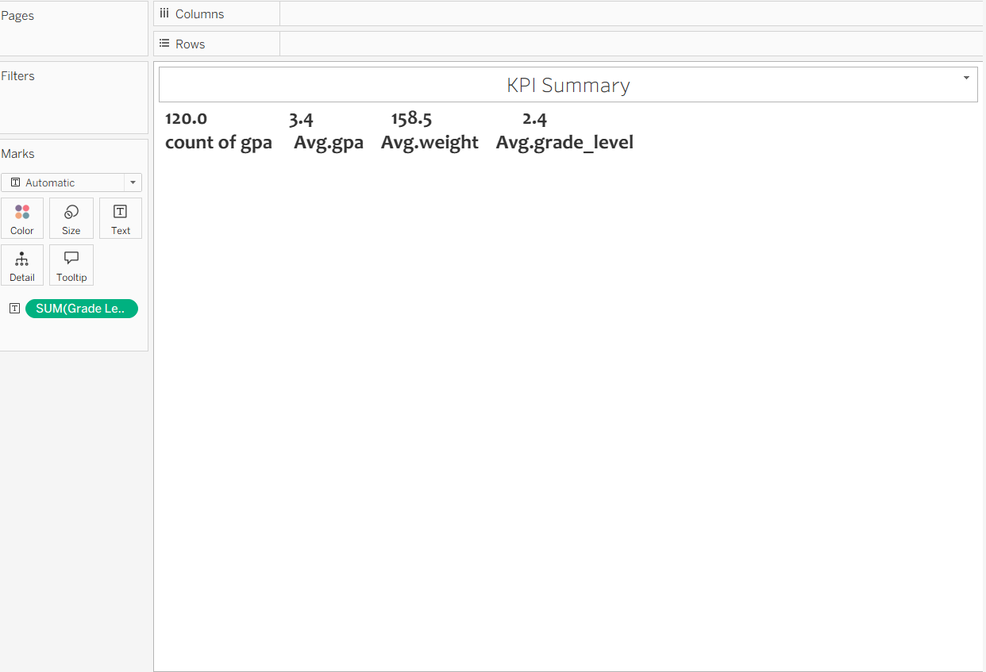

Sheet-2
Steps to create an Breakfast Consumption
1.First change the breakfast dimension
2.Drag the break fast to column
3.And its convert to CNT(Breakfast)
4.Drag the breakfast to row
5.There are two bars shows in the sheet
6.Change name for first bar to Cereal.
7.And also change name for second bar to Donut
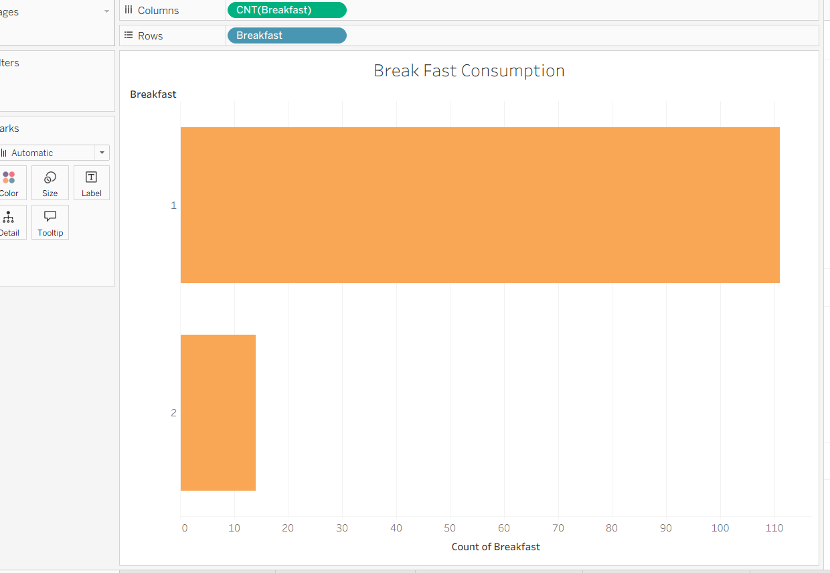

Sheet-3
Steps for create an Eating out Vs Cooking Frequency
1.Drag cook to column
2.Drag the eating out to Column
3.Drag the fruit day to rows
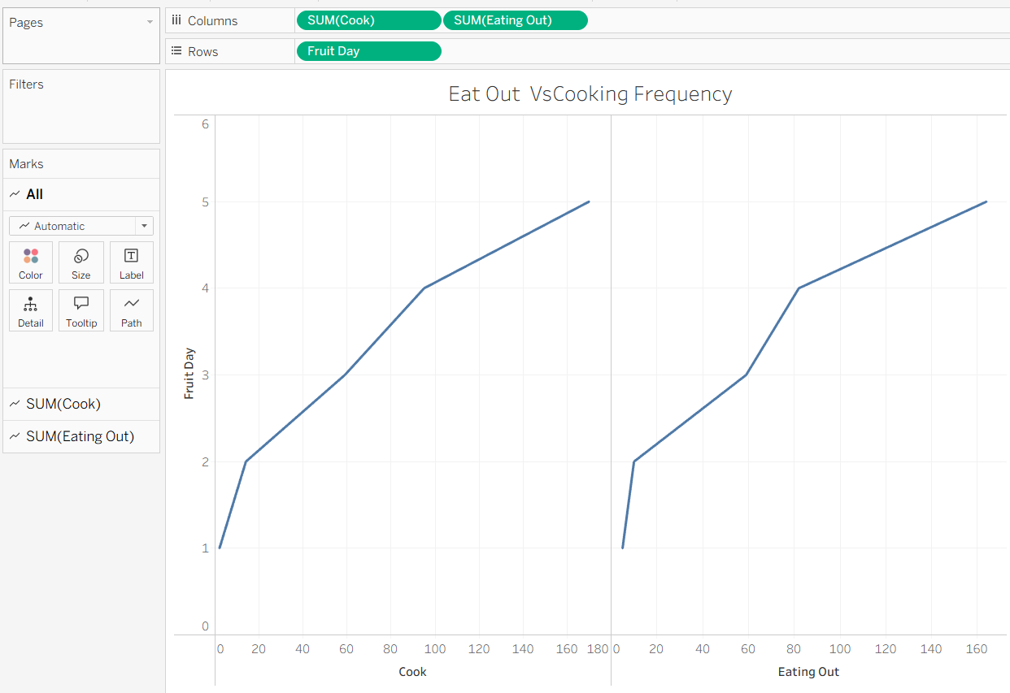

Sheet-4
Steps to create an Health Category by gender
1.Drag gender to colors.
2.Create Calculate field for Health Categories.
3.Then click on the analysis then show the rows click on Create Calculate field
Names as Health Categories then write formula
If[Healthy Feeling]>=8 THEN"Highly Healthy"
ELSEIF[Healthy Feeling]>=5 THEN"Moderately Healthy"
ELSE"less Healthy"
END
4.Then click on ok.
5.Drag Health Categories to Columns .
6.Drag Gender to rows.

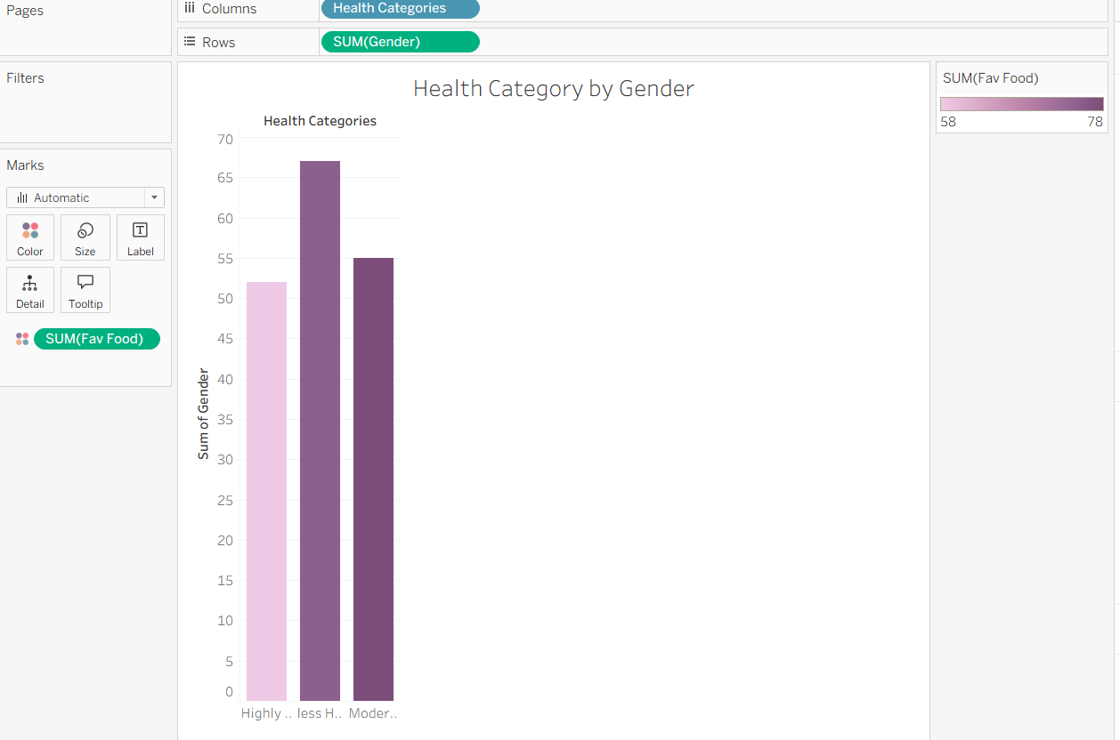

Sheet-5
Steps to create a Vitamins Consumption by Gender
1.Drag Fruit day to columns.
2.We have to create calculate field for Total Respondent.
3. Then click on the analysis then show the rows click on Create Calculate field
Name as Total Respondent then write formula
Count ([GPA])
4.Click on OK.
5.Drag the Total Respondent to Rows.
6.Gender to Colors.
7.Drag Vitamin users(%) to details.
8.In that Click on Aggregation it show like sum.
9.Then it show like sum (Vitamin Users).

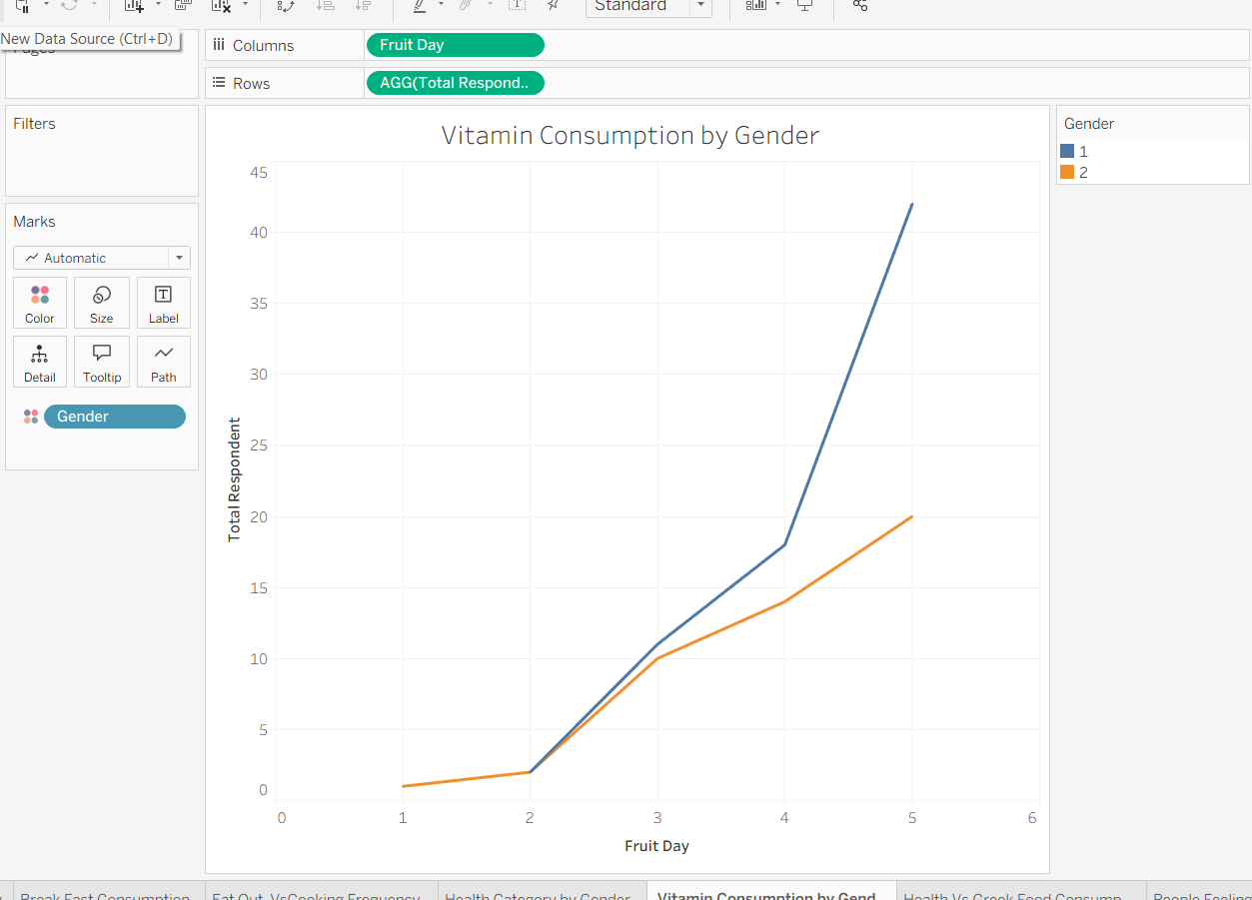

Sheet-6
Step for create an Health Vs Greek Food Consumption
1.Drag Health Categories to columns.
2.Drag measure names to columns, filters, colors.
3.Change the dimension for Exercise.
4.If you have to create Calculated field
5 . Then click on the analysis then show the rows click on Create Calculate field
Name as Average Exercise Frequency then write formula
Avg(Exercise)
6.Then click on ok
7.Drag measure Values to rows.
8.Its shows list of measures values in the sheet.
9.Remove the some rows in measure values.
10.If wants only 3 rows
=>AGG(Average Exercise Frequency)
=>Sum(Greek Food)
=>AGG(TotalRespondent)
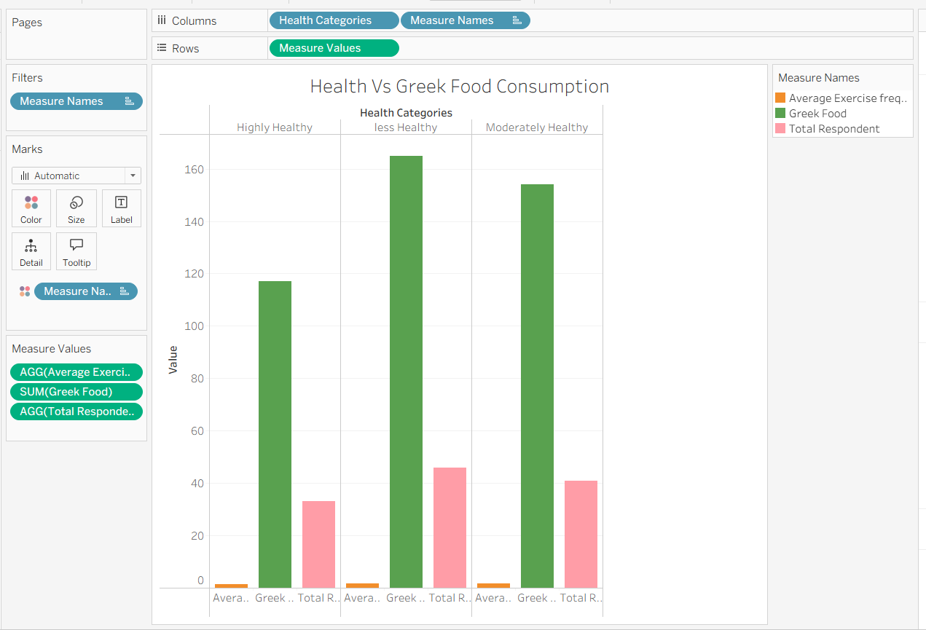

Sheet-7
Steps for Create a People Feeling Healthy and life rewarded
1.Drag Healthy Feeling to Size.
2.Drag Health Category to label.
3.Drag Gender to Colours.
4.In the marks cards show the Automatic its change to Circle.
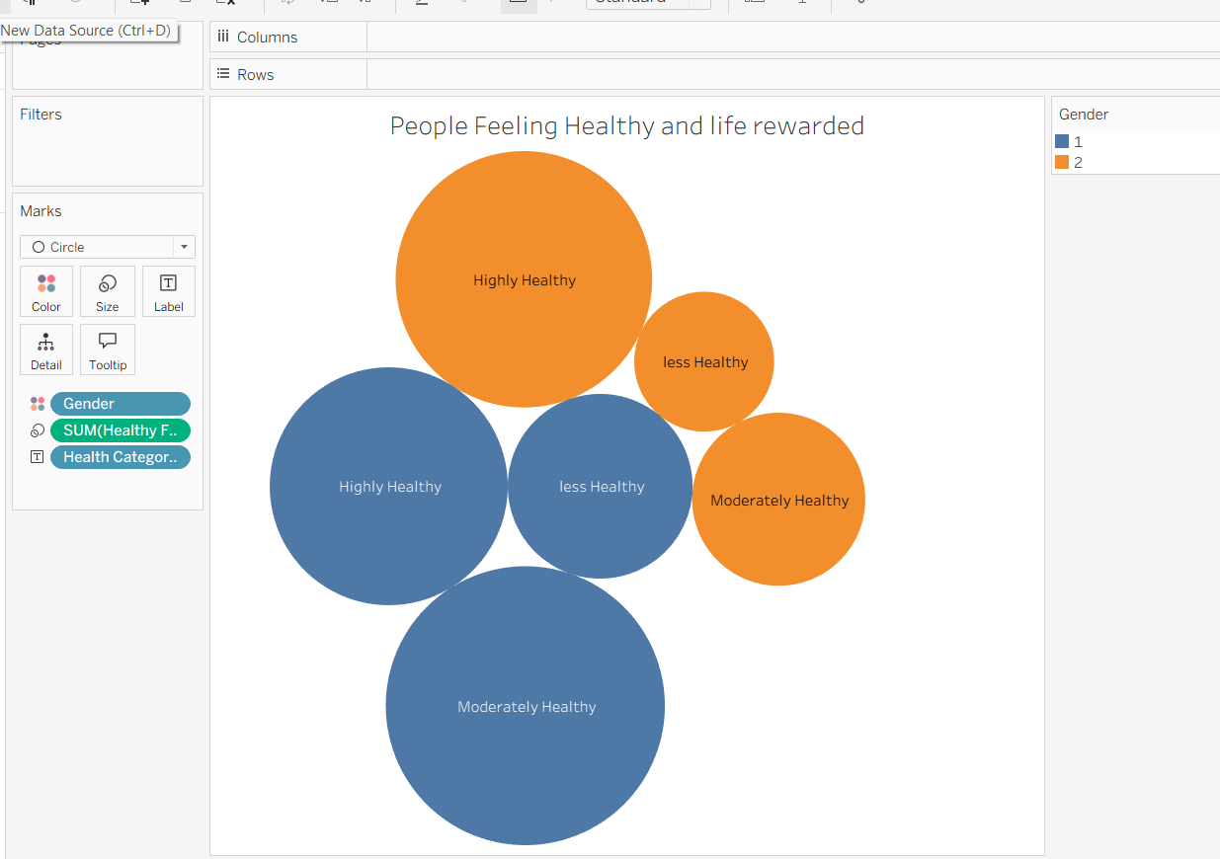
Sheet-8
Steps for Create a Weight Vs Exercise Frequency
1.Drag the average exercise frequency to size.
2.We have to create Calculate field for Breakfast.
3. Then click on the analysis then show the rows click on Create Calculate field
Name as Breakfast then write formula
Count([Breakfast]<>”No”)/[Total Respondents]*100.
4.Then Click on ok.
5.Drag Breakfast to Colors.
6. .We have to create Calculate field For weight categories

7. Then click on the analysis then show the rows click on Create Calculate fi
Name as weight categorie then write formula
IF [Weight] < 120 THEN "Under Weight"
ELSEIF [Weight] <= 180 THEN "Normal"
ELSE "Over Weight"
END
8.Then Click on ok.

9.DragWeight Categories to label.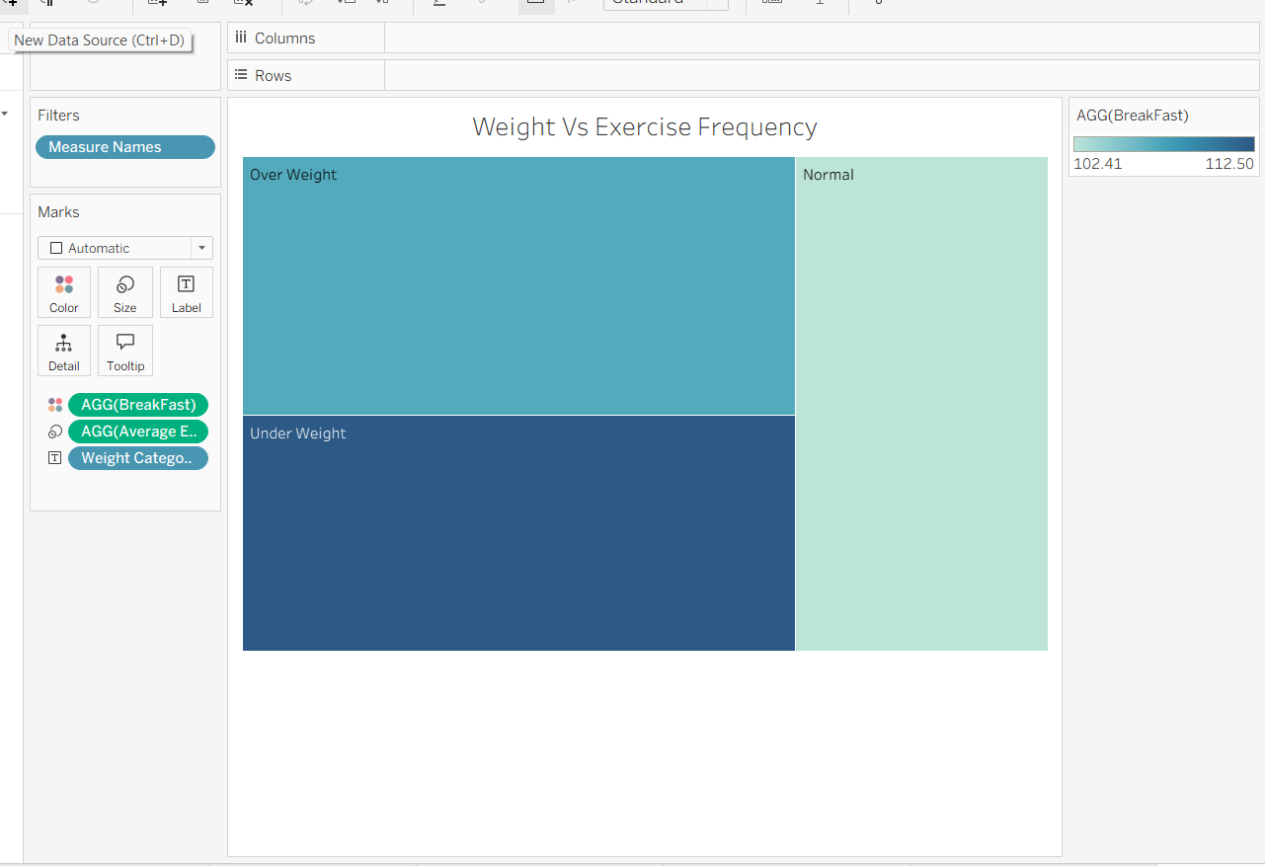

Sheet-9
Steps for Create Comfort food reasons
1.Drag Total Respondents to size.
2.Drag Comfort food to label
3.Drag the Average Exercise Frequency to color.

